Running Python code at the Command Line

Often data scientists write their code in a Jupyter notebook and then “refactor it” and refine it into a module that can be used at the command line.

You should have a plain text editor to work with.

This is a good introduction:

<https://opentechschool.github.io/python-beginners/en/getting_started.html>

Installing Python in Windows

There are two methods for installing python in windows

1. Installing python 3.5 and all its dependencies using Anaconda, which has been already explained in the previous tutorial
2. Installing python 3.5 separately

Running Python at command line in windows

Before running python at the command line in windows we have to make sure that the python is accessible from the command line.

1. 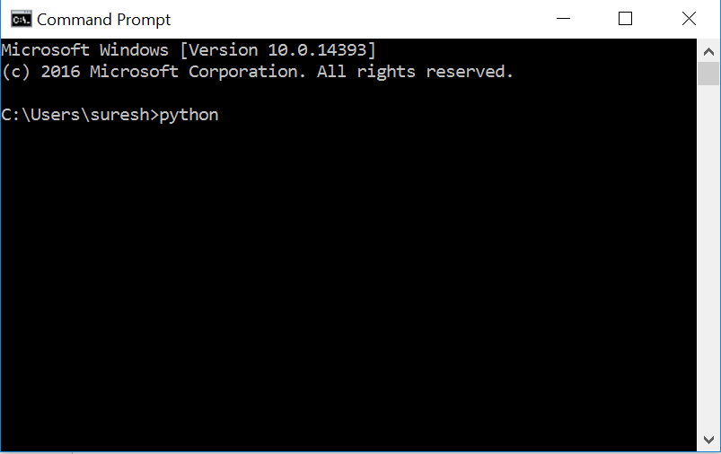After opening the command line in windows , type python and press enter

If python is installed correctly , you will get a screen like this .

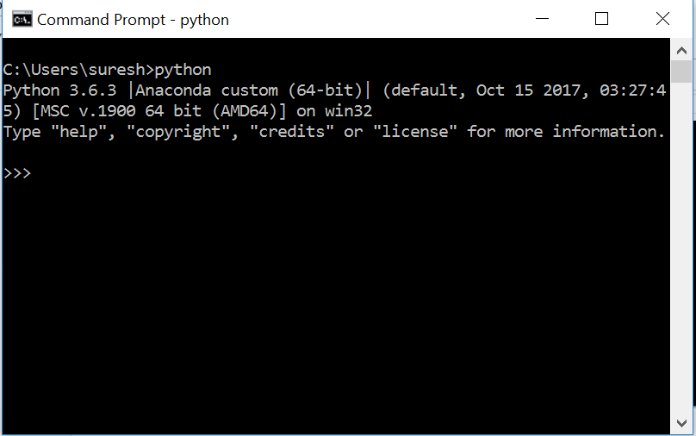

Else you will get an error message that says

***“'python' is not recognized as an internal or external command,***

***operable program or batch file.”***

This error means that you have not installed python properly or it’s not added to the *ENVIRONMENT*

Follow the steps to add python to the ENVIRONMENT

1. In Search, search for and then Control Panel
2. 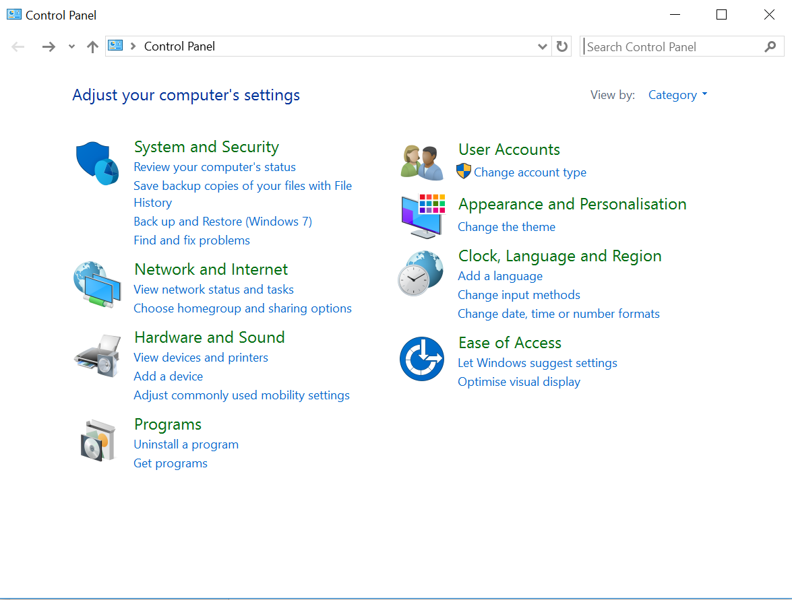In the control panel click on “SYSTEM AND SECURITY”
3. Then click on “SYSTEM”

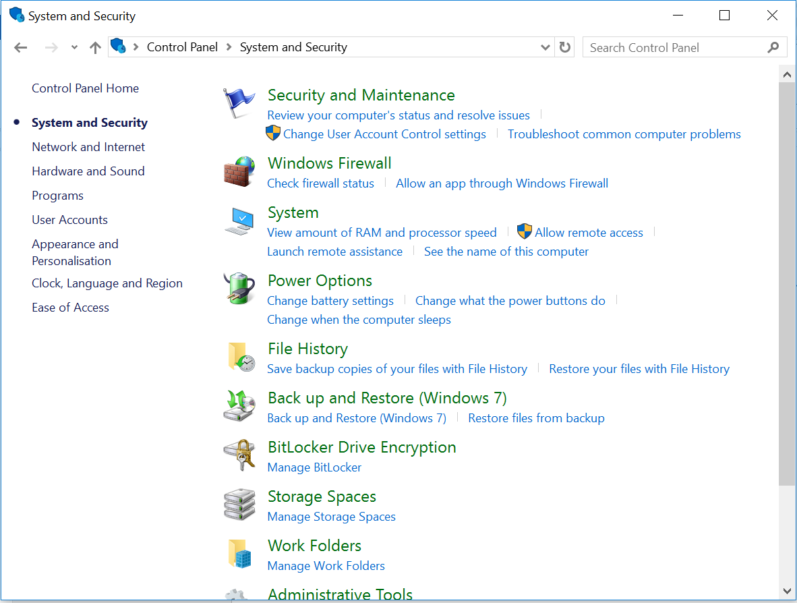…….

1. Then select “Advanced system settings” and a pop up will open

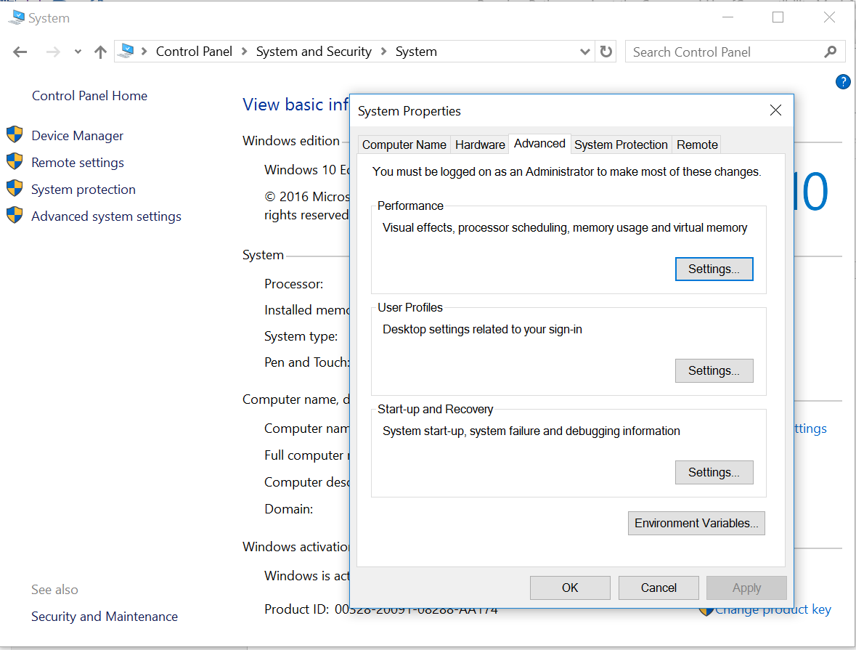

1. 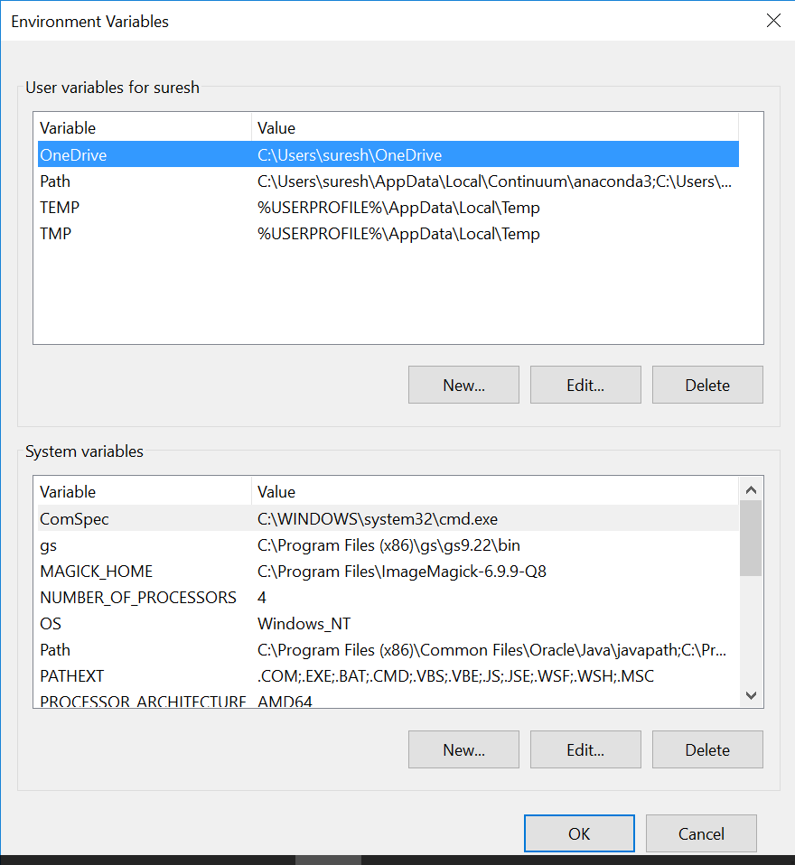From the popup select “Environment variables”, the following popup will open. Then double click on “path” from the systems variable
2. In the following popup which opens click on new

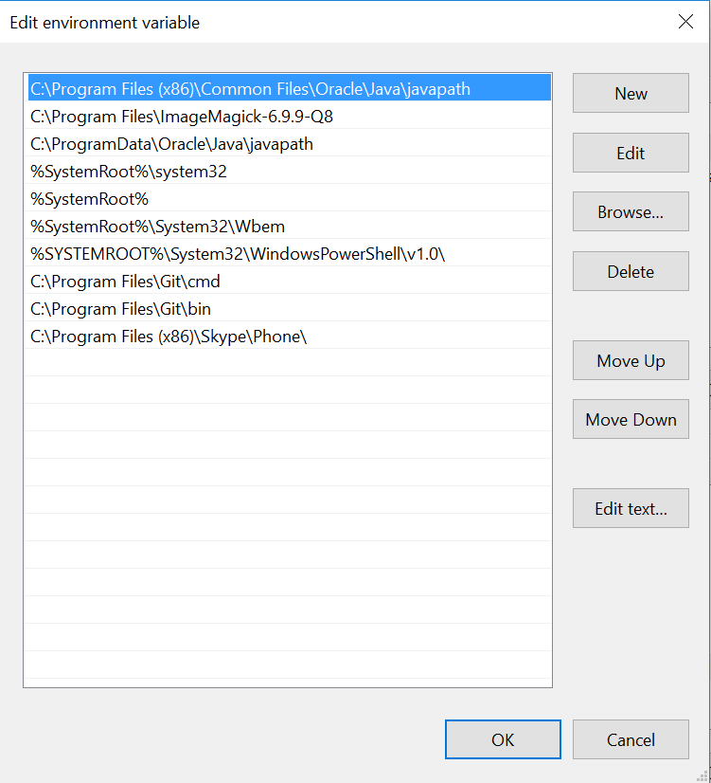

1. Then you will have to enter the path where your python is installed
   1. If you had installed through Anaconda the path will be similar to this

***“C:\Users\username\AppData\Local\Continuum\anaconda3\”***

* + 1. Then click on new again and enter

***“C:\Users\username\AppData\Local\Continuum\anaconda3\Scripts\”***

* 1. If you had installed python without Anaconda the path will be similar to

***“C:\Users\username\AppData\Local\Programs\Python\Python36-32\”***

* + 1. Then click on new again and enter

***“C:\Users\username\AppData\Local\Programs\Python\Python3632\Scripts\”***